Minhquan Nguyen

Brian Stanwood

Liam Byrne

Luke Deviney

**4010/4101/5102-091 Final Paper Project Report**

Our project utilized the Python language and Python’s machine learning technique by loading a dataset, analyzing that data through categorization and visualization, and then evaluating a prediction using an average with that data. The project asks for a date and predicts the worth of a BitCoin for that time specified. Our dataset was imported from the site Kaggle.com as a file named ‘BTC.csv’. The data then can be analyzed by the Python package Pandas and categorized by the columns in the dataset. Also, Matplotlib is a Python library we use to plot a 2D graph on the data and average line for better visualization. And finally the algorithm will take the date input or BitCoin amount of the user to predict the cost of a BitCoin based off of the pattern found.

Our programs starts in Step 1 by importing ‘Pandas’ to assist with manipulating the .csv data file which each entry is an approximate daily value, ‘Matplotlib’ for plotting the data, and ‘re’ for easy parsing of floats into currency format. Programming begins with reading the file, separating/assigning the columns to extract dates and prices, and using our average algorithm to find the average slope of the data results.

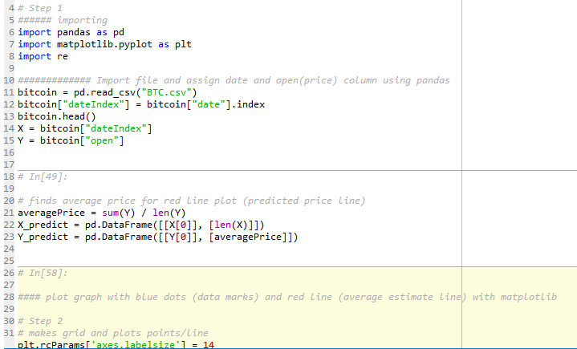

Next, Step 2 creates the plot grid, plots the data and displays the results as well as our slope line from the average algorithm.

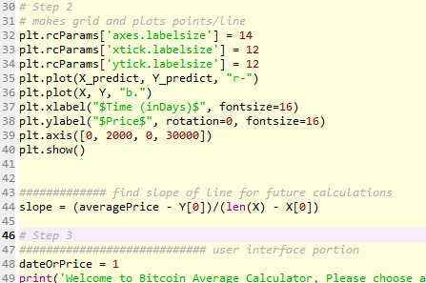

And finally, in Step 3, The user interface text is displayed for options to give a date or amount inquiry for BitCoin estimate as a while loop continues until the user is finished using the program.

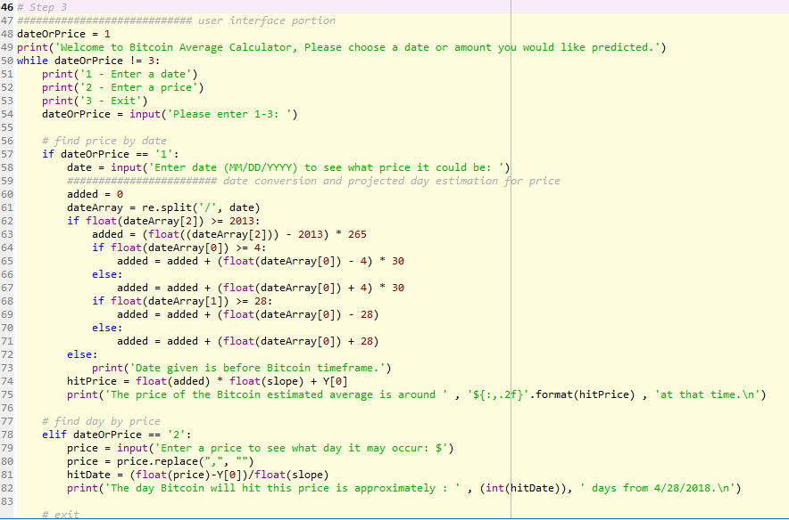

The end Product looks like this:

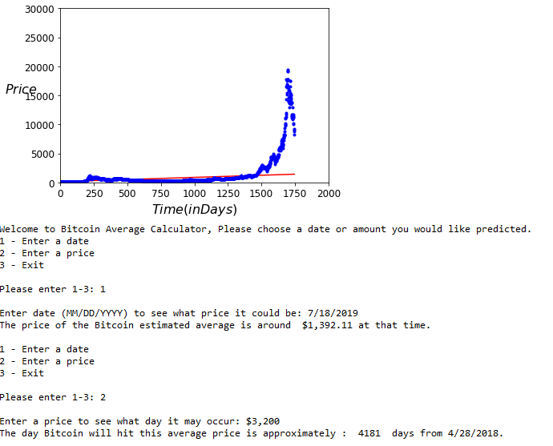

We chose Python as our language because none of us have any experienced working with Python before and thought it was a good opportunity to learn. The paradigm of Python is that it is very flexible. It can support a wide range of programming styles like objected oriented, imperative, procedural, functional, and reflective. Python was created by Guido van Rossum and released in 1991. Python’s design philosophy emphasizes code readability by using significant whitespace and provides constructs that enable clear programming on large and small scales. Unlike many languages that have primitive data types with keyword like ‘int’ for integers, Python does not require the use of an identifier. Instead Python supports type interfacing which pick out the most general compatible variable type to match the type.

Python’s readability is very simple since it operates like the English language. Unlike many programs that use curly braces and bracket to define a method/function, Python does not require the use of such. Writability and Readability goes together since you they go hand in hand. However, being able to read it doesn’t mean that you can write it. Python has thrived for over two decades so it must be Reliable. Python is a popular language among first learners as many tend to learn Python as their first or have been introduced to Python as their first programming language.

Some of the advantages of Python are that it is considered by many to be easy to learn, it supports many different platforms and systems. Python is extremely flexible and could be used to code practically anything from making websites, apps, to video games. Disadvantages of Python would be that it is slow. It could be used to make apps and video games, but the downside is that Python isn’t a good language for mobile apps and its low memory means that building high-graphic 3D video games is almost impossible on Python.